REGISTRATION

Leading Student Centered Coaching

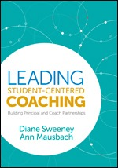

WHEN: January 23, 2020
8:30 am – 3:00 pm
LOCATION: TBD

Please complete and fax this form to Dr. Tammy Alexander @ 256 372-5774.

NAME: ___________________________________________________________

Email Address:_____________________________________________________

Phone Number:____________________________________________________

School District:_____________________________________________________

School:___________________________________________________________

If you have any questions, please contact Dr. Tammy Alexander @ 256-372-5771

